ON!Track Mobile User Manual
Mobile Manual Version 1.1

Table of Content
What is ON!Track? 2
How to download ON!Track from the App Store? 3
How to navigate in ON!Track Mobile App? 8
How to add a generic asset? 17
(a) Add a generic asset by using the integrated barcode scanner 19
(b) Add a generic asset by entering the data manually 23
(c) Add a generic asset by using a pre-defined template 25
(d) Add a generic asset without using a template 28
How to add a Hilti unique asset? 31
(a) Add a Hilti unique asset by using the integrated barcode scanner 33
(b) Add a Hilti unique asset by entering the data manually 41
How to add a commodity? 48
(a) Add a commodity by using the integrated barcode scanner 50
(b) Add a commodity by entering the data manually 54
How to add an asset to transfer list? 58
(a) Add an asset to transfer list by entering its Scan or Alternate Code 59
(b) Add an asset to transfer list by using the search function 62
(c) Add an asset to transfer list by using the integrated barcode scanner 68
How to confirm a delivered asset? 74
How to perform an inventory check? 77
(a) Inventory check by using the integrated barcode scanner 80
(b) Inventory check by using the search function 83
(c) Inventory check by looking through the asset list manually. 87
How to view an item? 92
(a) View item by using the integrated barcode scanner 93
(b) View item by using the search function 97
(c) View item by using the integrated barcode scanner 101
How to identify an item? 104
How to edit the settings? 107
How to check if there is Un-synced Data? 111
How to log out of ON!Track? 113

What is ON!Track?
Hilti ON!Track is the professional solution for managing all of your assets, regardless of manufacturer. The software makes it easy to track and search for assets to minimize losses, to maintain inventory lists quickly and easily, all in one place, and to get automated alerts as reminders for repairs, servicing and inspections.

How to download ON!Track from the App Store?
- Go to Google Play Store on your mobile device.
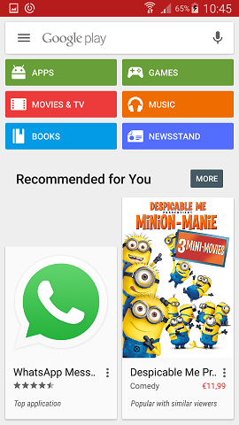

- Type in “Hilti on track” in the search bar.

- Click on the search result in the dropdown.
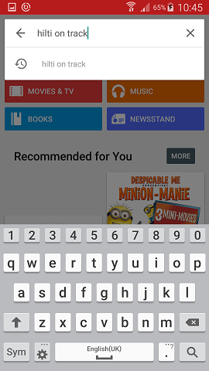

- Click on Hilti ON!Track in the App section of the search result page.
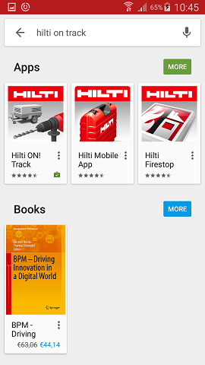

- Click on Install to install the ON!Track on your mobile device.
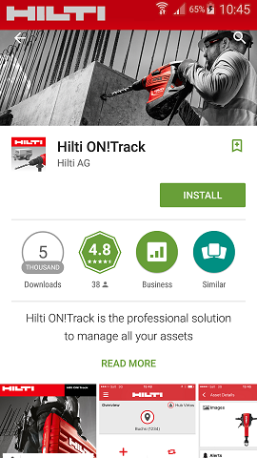

How to navigate in ON!Track Mobile App?
- Once you start the ON!Track mobile app, the first view is the overview screen; here you can decide if you would like to add an item, transfer an item to another location, confirm the delivery of a transferred item, check inventory at your location, look up an item, or identify item by using the barcode scanner.
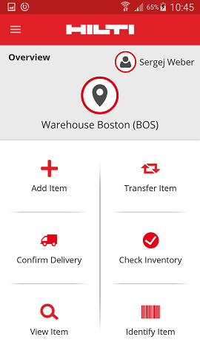

- You also can click on the Menu icon to see the vertical navigation bar with all the action icons from the overview screen as well as the app settings and possibility to log out.

- In general, you have to fill all mandatory fields (marked red) to proceed to the next process step; in the case that not all mandatory fields are filled, the button to continue is grayed-out meaning inactive.
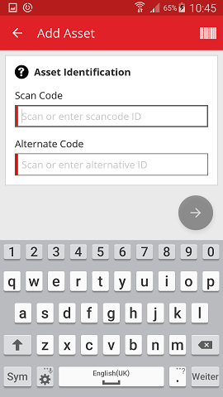

- In order to proceed to next process steps, click on a red arrow button.
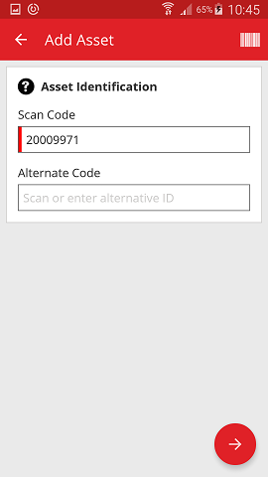

- In order to complete actions, click on the red checkmark button.
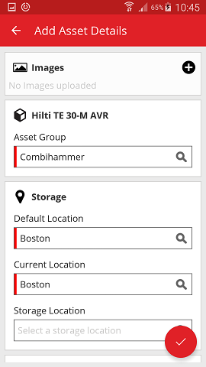

- In order to confirm an entry date, click on OK on the keyboard,
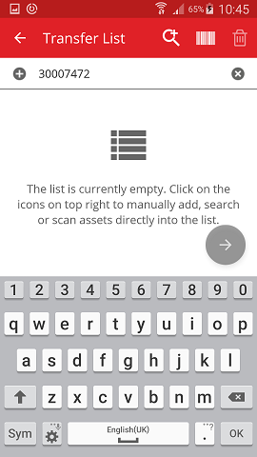
- In order to go back in the process, click on the arrow pointing to the left.

- If there is an item list to choose from, scroll through the list and click on the corresponding line.
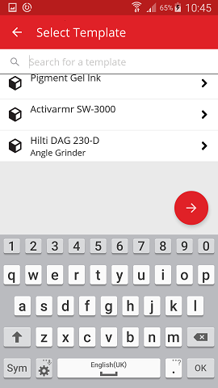

- Where applicable, a magnifying glass icon, a barcode icon, and a trash bin icon are shown in the upper navigation; by clicking on the magnifying glass icon you can search for an item, by clicking on the barcode icon you activate the barcode scanner, and by clicking on the trash bin icon you delete a pre-selected item.
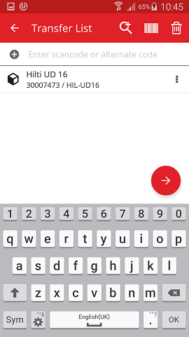

How to add a generic asset?
- Click on Add Item on the start screen.

- Click on Generic Asset to add a respective asset.

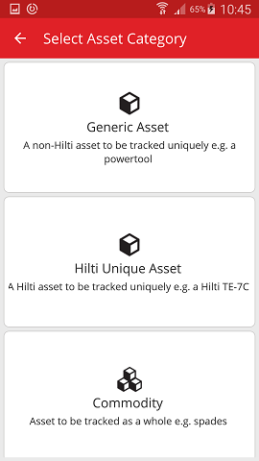
- Here, you have two options how to continue: (a) by using the integrated barcode scanner or (b) by entering the data manually.

Add a generic asset by using the integrated barcode scanner
- Select the text field that should be filled with the scanned data by clicking into the respective text field (i.e. Scan Code, Alternate Code, or Serial Number); a thicker frame indicates a selected field.
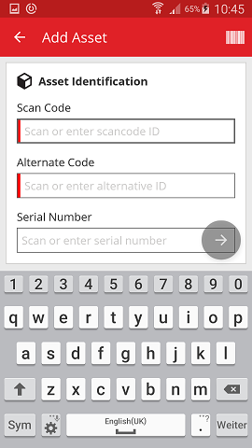

- Click on the barcode icon to pre-fill the selected text field.

- Capture the barcode of the respective item with the camera of your mobile device; as soon as the barcode is in focus, it is scanned and data is pre-filled into the selected text field automatically.
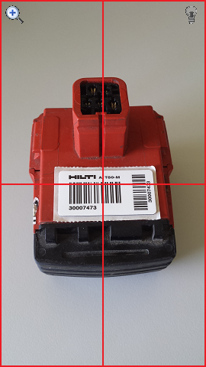

- Click on the red arrow button to continue.

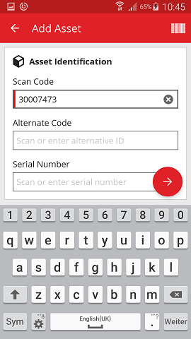

Add a generic asset by entering the data manually
- Fill in the Scan Code and/or Alternate Code into the respective text field; mandatory fields are marked red.

Note: Although here the entry of the Serial Number is not mandatory, a complete data entry is advised.
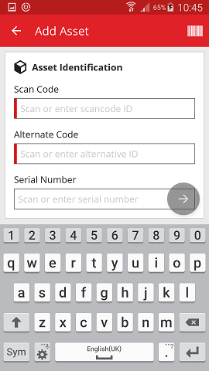

- Click on the red arrow button to continue.

Note: As long as the mandatory fields (marked red) are not filled, the button to continue is grayed-out meaning inactive.

- At this point, again, you have two options how to proceed: (c) by using a pre-defined template to pre-fill data if available or (d) by entering the data manually.

Add a generic asset by using a pre-defined template
Note: In order to add assets by using templates, they must have been previously added to ON!Track; you can only add templates in the ON!Track web application.

- Select the template that matches with the asset to be added by scrolling through the list and clicking on the corresponding line.

- Fill out the data required; mandatory fields are marked red.
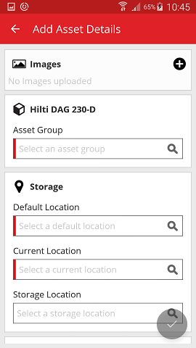

- Click on the red checkmark button to complete the addition of the new asset.
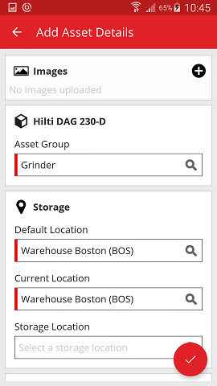

Add a generic asset without using a template
- Click on the red arrow button to continue.

- Fill out the data required; mandatory fields are marked red.
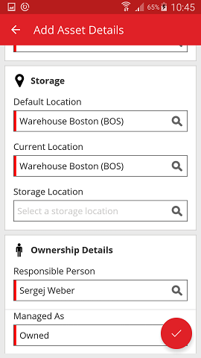

- Click on the red checkmark button to complete the addition of the new asset.

Note: Although here, the entry of Manufacturer and Model is not mandatory, a complete data entry is advised.

How to add a Hilti unique asset?
Note: In order to be able to add, i.e. register, a Hilti unique asset, the asset to be registered needs to be purchased by the same Hilti client who is the purchaser of the software. The registration of a Hilti unique asset requires less effort then a Generic asset since some of the Hilti unique asset data is pre-populated during the process of adding a Hilti item.

- Click on Add Item on the start screen.

- Click on Hilti Unique Asset to add a respective asset.

- Here, you have two options how to continue: (a) by using the integrated barcode scanner or (b) by entering the data manually.

Add a Hilti unique asset by using the integrated barcode scanner

- Select the text field that should be filled with the scanned data by clicking into the respective text field (i.e. Scan Code, Alternate Code, or Serial Number); a thicker frame indicates a selected field.

- Click on the barcode icon to pre-fill the selected text field.

- Capture the barcode of the respective item with the camera of your mobile device; as soon as the barcode is in focus, it is scanned and data is pre-filled into the selected text field automatically.

- Fill out the serial number of the asset to be added.
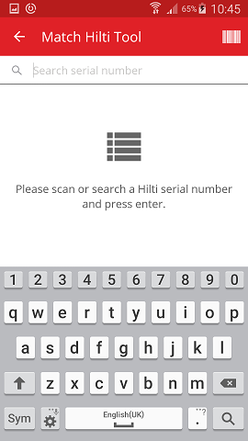

- Click on the magnifying glass icon on the keyboard of your mobile device to confirm the entry.
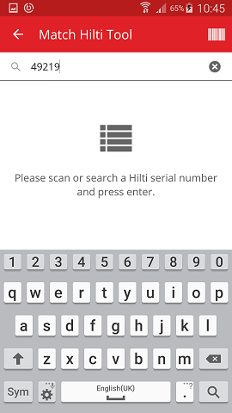

- Click on the matching search result to continue.
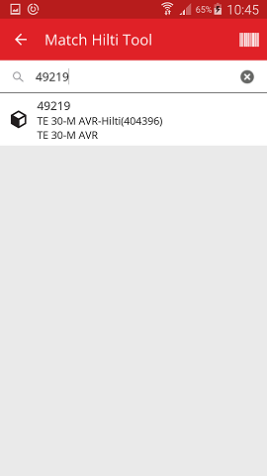

- Fill out the data required; mandatory fields are marked red.
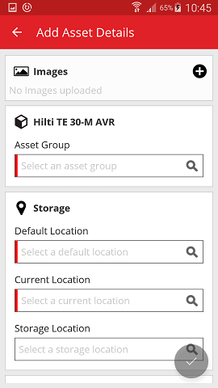

- Click on the red checkmark button to complete the addition of the new asset.

Add a Hilti unique asset by entering the data manually
- Fill in the Scan Code and/or Alternate Code into the respective text field; mandatory fields are marked red.

- Click on the red arrow button to continue.

Note: As long as the mandatory fields (marked red) are not filled, the button to continue is grayed-out meaning inactive.

- Fill out the serial number of the asset to be added.

- Click on the magnifying glass icon on the keyboard of your mobile device to confirm the entry.

- Click on the matching search result to continue.

- Fill out the data required; mandatory fields are marked red.

- Click on the red checkmark button to complete the addition of the new asset.

How to add a commodity?
- Click on Add Item on the start screen.

- Click on Commodity to add a respective asset.

- Here, you have two options to continue: (a) by using the integrated barcode scanner or (b) by entering the data manually.

Add a commodity by using the integrated barcode scanner
- Select the text field that should be filled with the scanned data by clicking into the respective text field, i.e. Scan Code or Alternate Code; a thicker frame indicates a selected field.
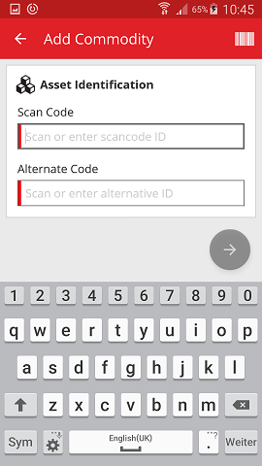

- Click on the barcode icon to pre-fill the selected text field.

- Capture the barcode of the respective item with the camera of your mobile device; as soon as the barcode is in focus, it is scanned and data is pre-filled into the selected text field automatically.

- Click on the red arrow button to continue.

Note: As long as the mandatory fields (marked red) are not filled, the button to continue is grayed-out meaning inactive.
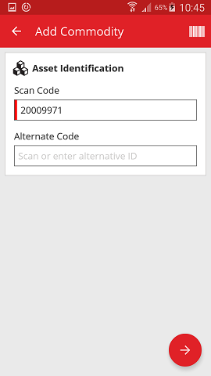

Add a commodity by entering the data manually
- Fill in the Scan Code and/or Alternate Code into the respective text field; mandatory fields are marked red.

- Click on the red arrow button to continue.

Note: As long as the mandatory fields (marked red) are not filled, the button to continue is grayed-out meaning inactive.

- Fill out the data required; mandatory fields are marked red.
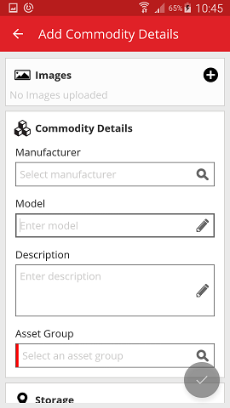

- Click on the red checkmark button to complete the addition of the new commodity.
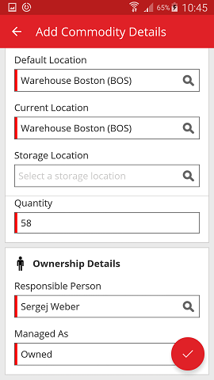

How to add an asset to transfer list?
- Click on Transfer Item on the start screen.

- Here, you have three options how to add an asset to transfer list: (a) by entering the scan or alternate code (b) by using the search function, or (c) by using the integrated barcode scanner.

Add an asset to transfer list by entering its Scan or Alternate Code
- Fill in the Scan and/or Alternate Code of the asset to be transferred into the text field.
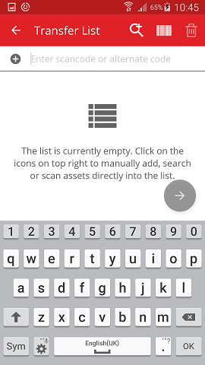

- Click OK on the keyboard of your mobile device to confirm the entry.

- Click on the red arrow button to continue.
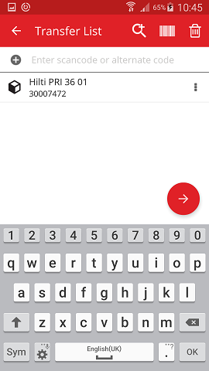

Add an asset to transfer list by using the search function
- Click on the magnifying glass icon to search for the asset to be transferred.

- Fill in any information of the asset to be transferred into the text field, e.g. friendly name, scan code, or alternate code.
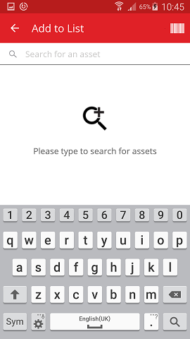

- Click on the magnifying glass icon on the keyboard of your mobile device to confirm the entry.
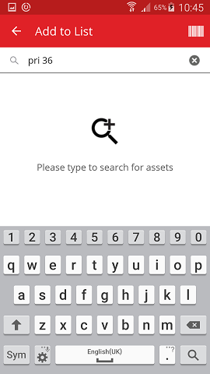

- Select the asset to be transferred by clicking on the respective box icon.
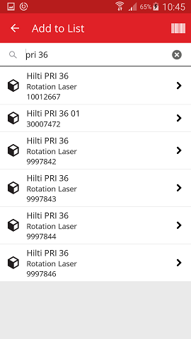

- Click on Add to List to get back to the Transfer List.

Tip: Select more than one tagged asset to bulk-process items to be transferred.
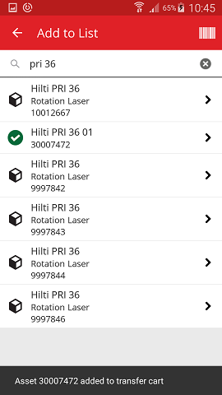

- Click on the red arrow button to continue.
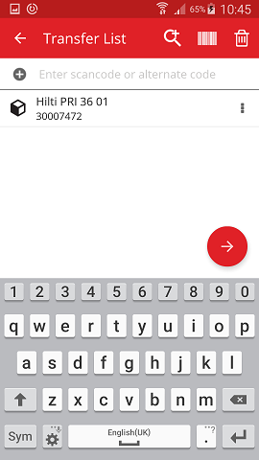

Add an asset to transfer list by using the integrated barcode scanner

- Click on the barcode icon to identify the asset to be transferred.

- Capture the barcode of the respective item with the camera of your mobile device; as soon as the barcode is in focus, it is scanned and the count is incremented.

Tip: Scan more than one tagged asset to bulk-process items to be transferred.
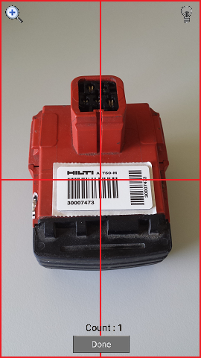

- Click on Done to finish the scanning.

- Click on the red arrow button to continue.

- Fill out the data required; mandatory fields are marked red.
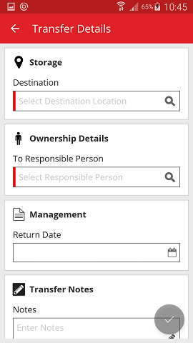

- Click on the red checkmark button to transfer the respective asset.
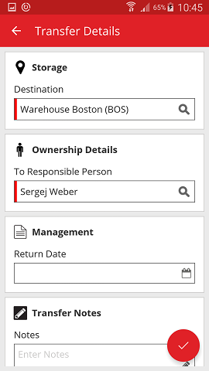

How to confirm a delivered asset?
Note: In order to be able to confirm delivered assets, this functionality has to be activated by your ON!Track Admin user.

- Click on Confirm Delivery on the start screen.

- Confirm the delivery of an asset by clicking on the respective box icon.

- Click on the red checkmark button to return to the start screen.

How to perform an inventory check?
- Click on Check Inventory on the start screen.

- Click on the location where the inventory check has to be performed.
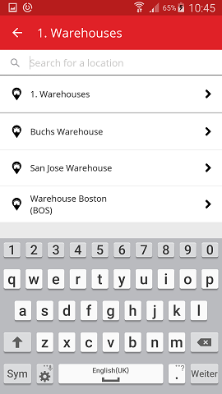

- Before clicking on the red arrow button to continue, see your current inventory check status in the summary; the percentage bar indicates the degree of completion of your inventory check.

Note: In order to start a new inventory check, please click on the trash bin icon.
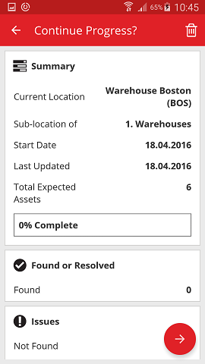

- Here, you have three options how to continue: (a) by using the integrated barcode scanner, (b) by using the search function, or (c) by looking through the asset list and comparing it with the stock in the location manually.

Note: The question-mark tab shows all assets to be checked, the exclamation-mark tab shows assets actually assigned to another location, and the check-mark tab shows assets located in the location intended.

Inventory check by using the integrated barcode scanner
- Click on the barcode icon.
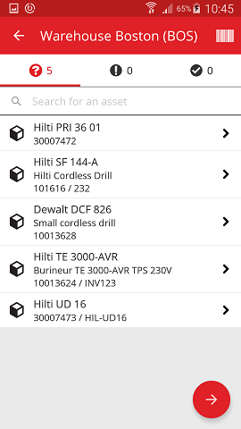

- Capture the barcode of the respective item with the camera of your mobile device; as soon as the barcode is in focus, the item is scanned and compared automatically with the stock in the system.

- Repeat scanning until all items in your inventory are captured.

Note: Your system is consistent if the item list is empty and there are no entries in the exclamation-mark tab after you scanned all your items.

If a scanned item is actually assigned to another location, it is listed in the exclamation-mark tab; if the scanned item is located in the location intended, it is listed in the check-mark tab.
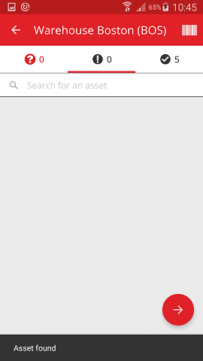

Inventory check by using the search function
- Fill in any information of the asset to be searched into the text field, e.g. friendly name, scan code, or alternate code.
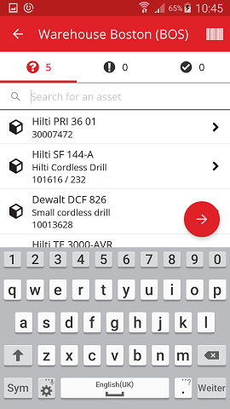

- Click on the asset to confirm that it is in your local inventory.
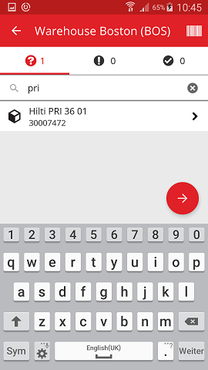

- Click on the x icon to clear the search request and to return to the item list view.

- Repeat searching and confirming items in your inventory until all of them are captured.

Note: Your system is consistent if the item list is empty and there are no entries in the exclamation-mark tab after you captured all your items.

If a captured item is actually assigned to another location, it is listed in the exclamation-mark tab; if the scanned item is located in the location intended, it is listed in the check-mark tab.

Inventory check by looking through the asset list manually.
- Click on an asset to confirm that it is in your local inventory.

- Repeat confirming items in your inventory until the item list is empty.

Note: Following this approach, your system is consistent if there are no additional items to confirm in your inventory and the item list is empty.

If the item list is empty but there are still items to be confirmed, please use the integrated barcode scanner to capture the items.

- Click on the red arrow button to continue.

- See your current inventory check status in the summary; the 100% indicates that the inventory check has been fully performed.
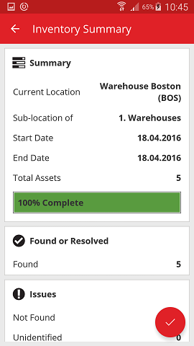
- Click on the red checkmark button to complete the inventory check.

Note: If the functionality is activated in the ON!Track web application, you will get a summary of the inventory check by mail.

How to view an item?
- Click on Identify Item on the start screen.

- Here, you have three options how to continue: (a) by using the integrated barcode scanner, (b) by using the search function, or (c) by looking through the asset list on the respective item tabs

View item by using the integrated barcode scanner
- Click on the barcode icon.
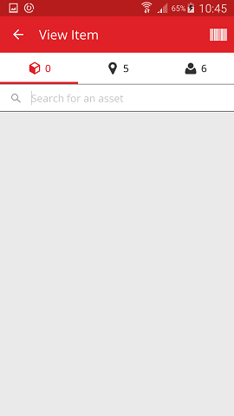

- Capture the barcode of the respective item with the camera of your mobile device; as soon as the barcode is in focus, it is scanned and the item list is displayed.
- Click on the item to see the respective details.
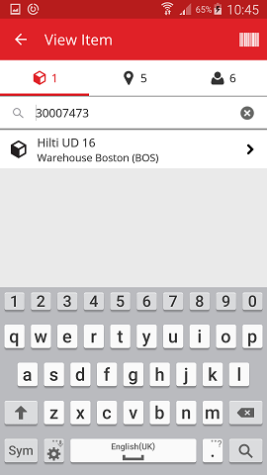

- View the asset information on the Asset Details screen.
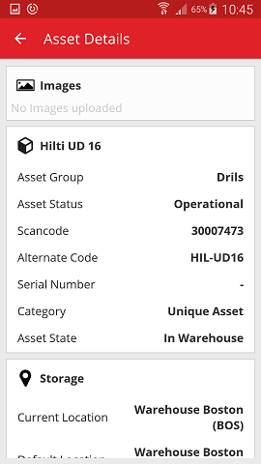

View item by using the search function
- Fill in any information of the asset to be viewed into the text field, e.g. friendly name, scan code, or alternate code.
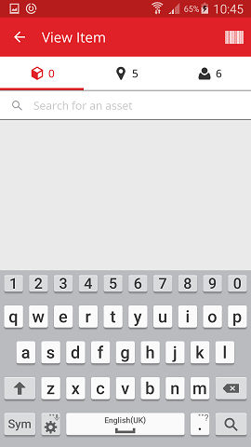
- Click on the magnifying glass icon on the keyboard of your mobile device to confirm the entry.
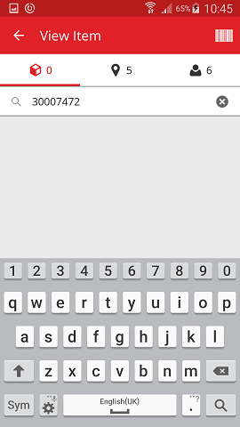

- Click on the item to see the respective details.
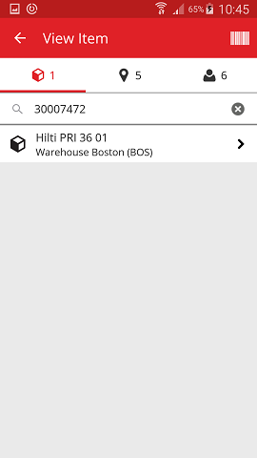

- View the asset information on the Asset Details screen.
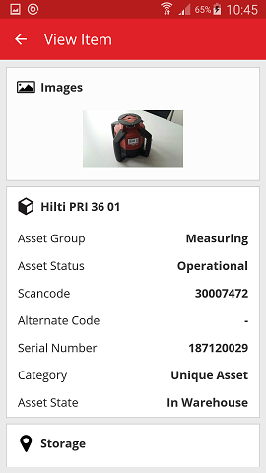

View item by using the integrated barcode scanner
- Navigate to Locations tab to see all the items assigned to the pre-defined location.

Note: The location can be changed under Settings; in order to see all items you as a user are responsible for, see the Person tab.

- Click on the item to see the respective details.
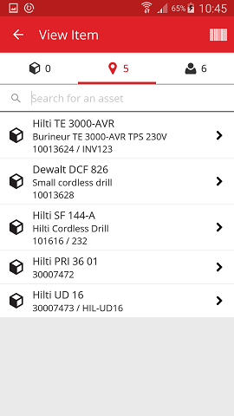

- View the asset information on the Asset Details screen.
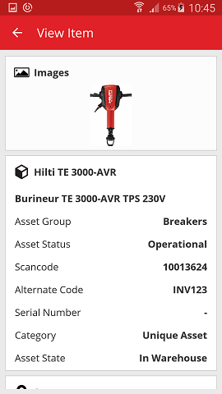

How to identify an item?
- Click on Identify Item on the start screen.

- Capture the barcode of the respective item with the camera of your mobile device; as soon as the barcode is in focus the Asset Details screen with asset information is displayed.

- See the asset information on the Asset Details screen.

How to edit the settings?
- Click on Menu icon on the start screen to see the navigation.

- Click on Settings to see the settings.
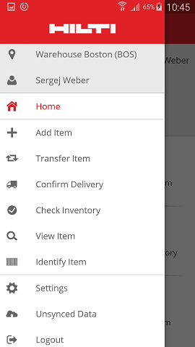

- Change Current Location or Language by clicking inside the respective field and selecting the desired location or language.

Note: See the ON!Track web application for advanced settings.
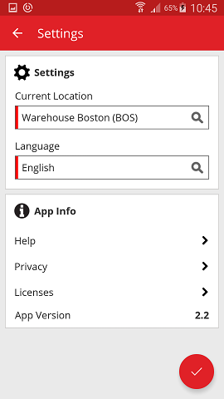

- Click on the red checkmark button to complete the editing of the settings.

How to check if there is Un-synced Data?
Note: In case of failed internet connection during the data synchronization between the mobile app and the ON!Track servers, the result might be un-synced data – meaning the data in the mobile app is not consistent with the data in the ON!Track web application; usually, this problem is solved as soon as the mobile device is back online again.

- Click on Menu icon on the start screen to see the navigation.

- Click on Un-synced Data.

How to log out of ON!Track?
- Click on Menu icon on the start screen to see the navigation.

- Click on Logout.

